Experiment No. 10

**Aim:** To perform Port, Service monitoring, and Windows/Linux server monitoring using Nagios.

# LO:

* **LO1:** To explain the fundamentals of cloud computing and be fully proficient with Cloud-based DevOps Solution deployment Options to meet your business requirements.
* **LO5:** To use continuous monitoring tools to resolve any system errors (low memory, unreachable server, etc) before they have any negative impact on the business productivity.

# Theory:

**Server Monitoring With Nagios**

**Capabilities**

Nagios is recognized as the top solution to monitor servers in a variety of different ways. Server monitoring is made easy in Nagios because of the flexibility to monitor your servers with and without agents. With over 3500 different addons available to monitor your servers, the community at the Nagios Exchange has left no stone unturned.

Nagios is fully capable of monitoring Windows servers, Linux servers, Unix servers, Solaris, AIX, HP-UX, Mac OS/X, and more.

**Benefits**

Implementing effective server monitoring with Nagios offers the following benefits:

* Increased server, services, process, and application availability
* Fast detection of network and server outages and protocol failures
* Fast detection of failed servers, services, processes and batch jobs

**Implementation:**

**Step 1:** Tactical Overview

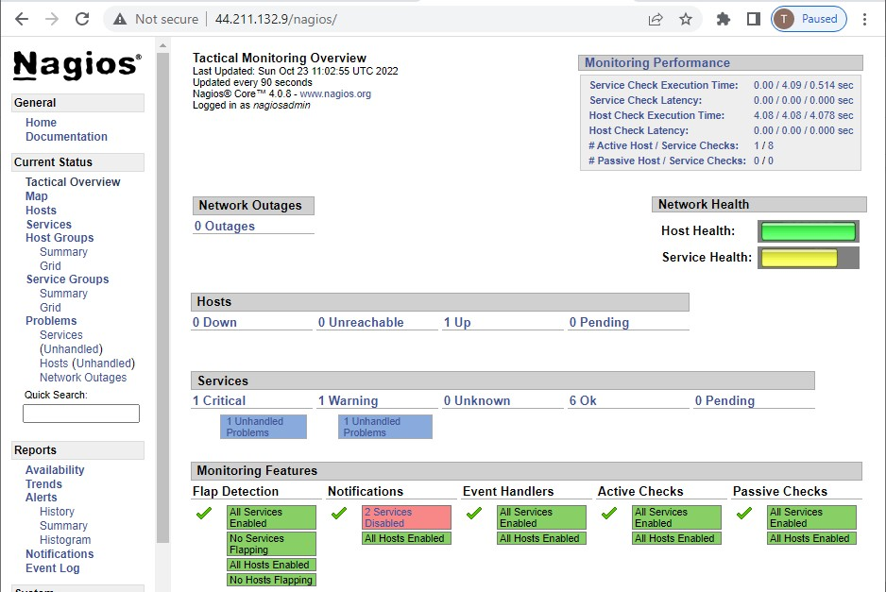

**Step 2:** Map

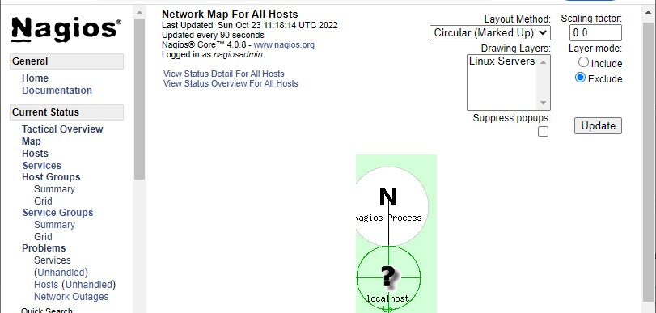

**Step 3:** Hosts

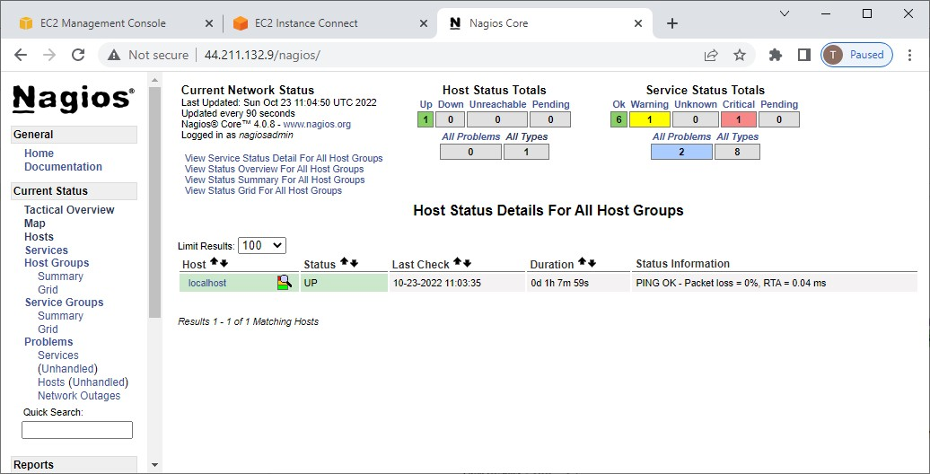

**Step 4:** Hosts group

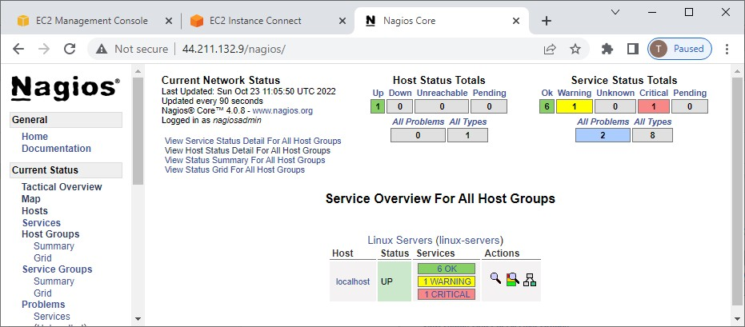

## Summary

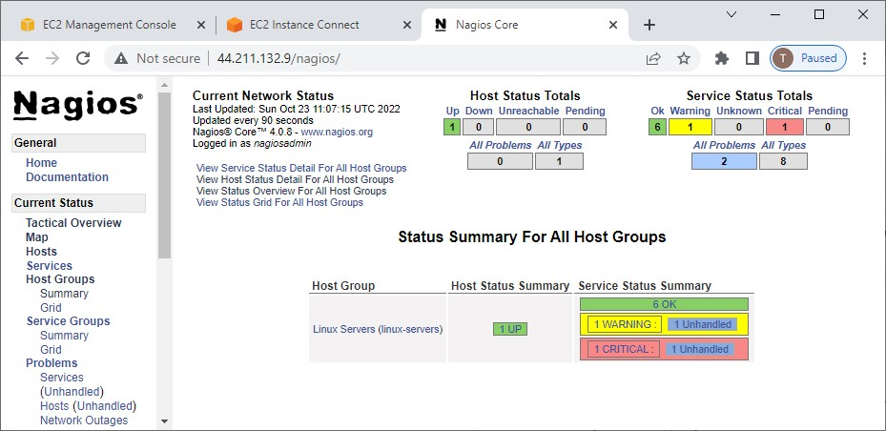

Grid

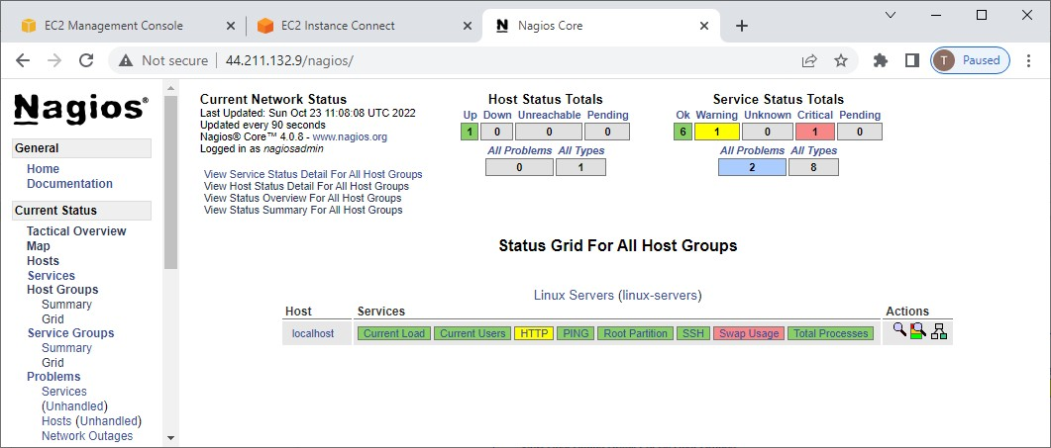

**Step 5:** Problems

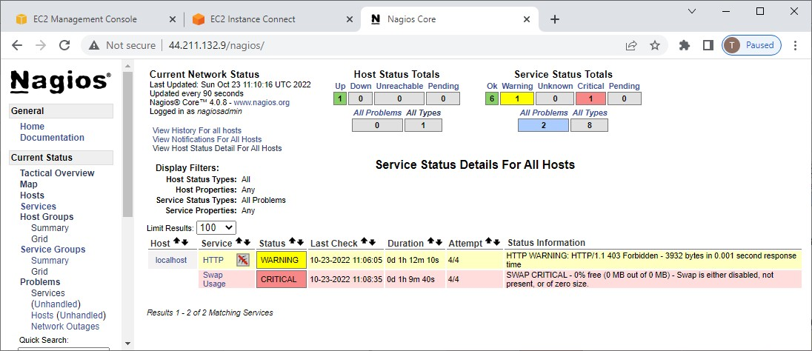

**Step 6:** History

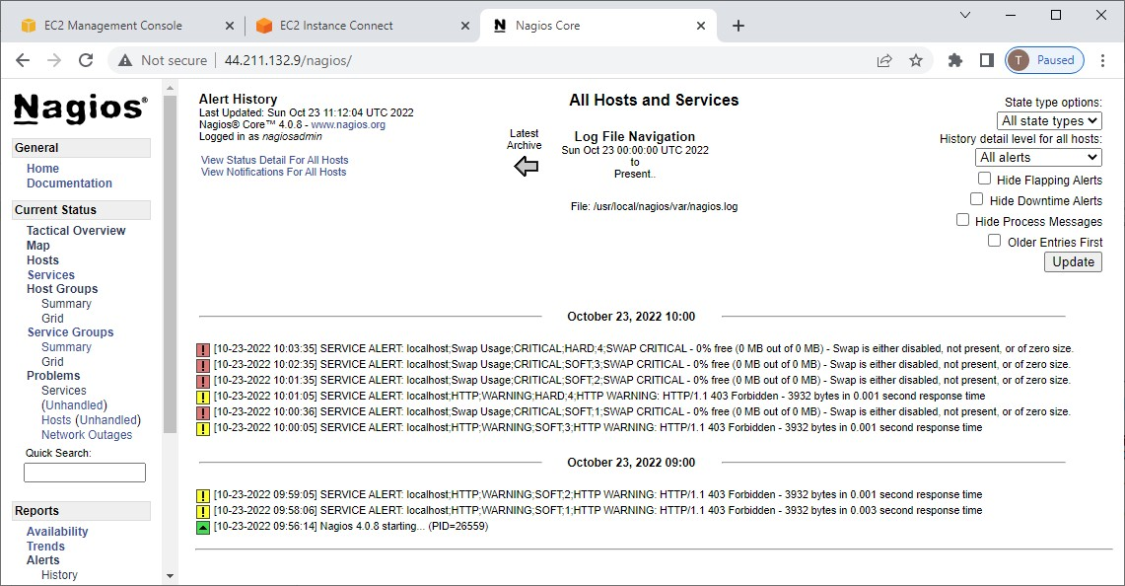

**Conclusion:** From this experiment, I have understood the concept of server monitoring using the Nagios tool on different ports and services which are being used and served by the server and successfully achieved LO1, LO5, PO1-PO5, PO9, PO10, and PO12.